

# *UniX and Linux Essentials*

**ASSIGNMENT -9**

**SUBMITTED BY:**

**AYUSH KUMAR JHA**

**SAP ID - 500086400**

**Enrollment no - R200220083**

**B.C.A -I.O.T.**

**Assignment 9: -**

**1.cd / - directory**

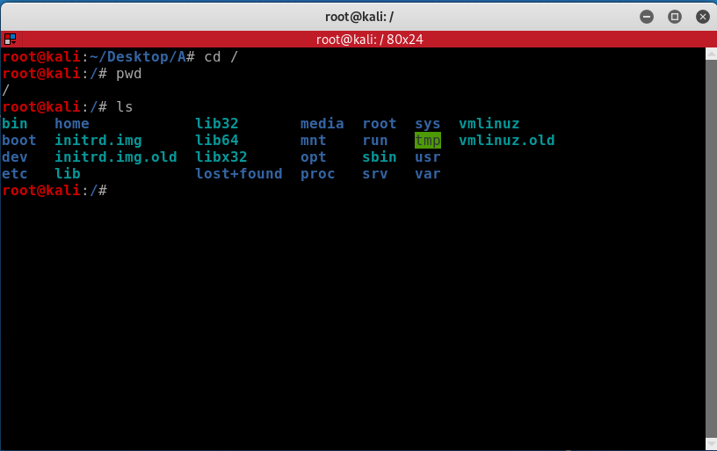

2.Adduser name – Adiing a user

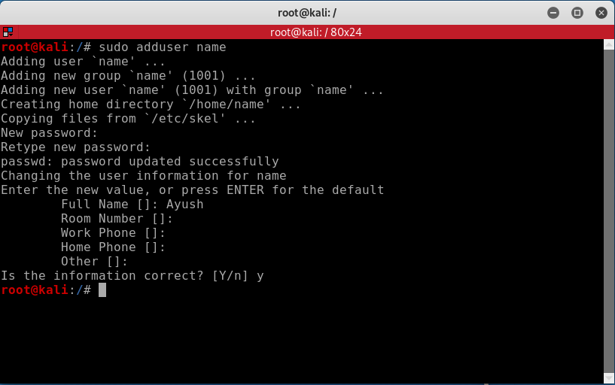

3.ls -l for long defined list

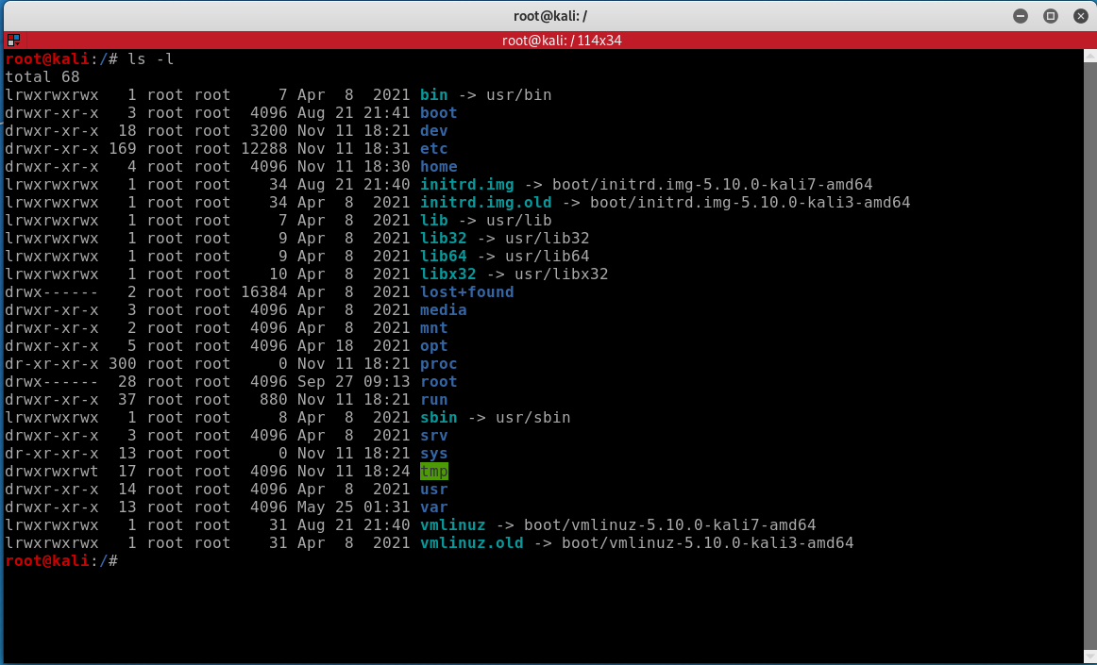

4. ls -n long list with UID And GID

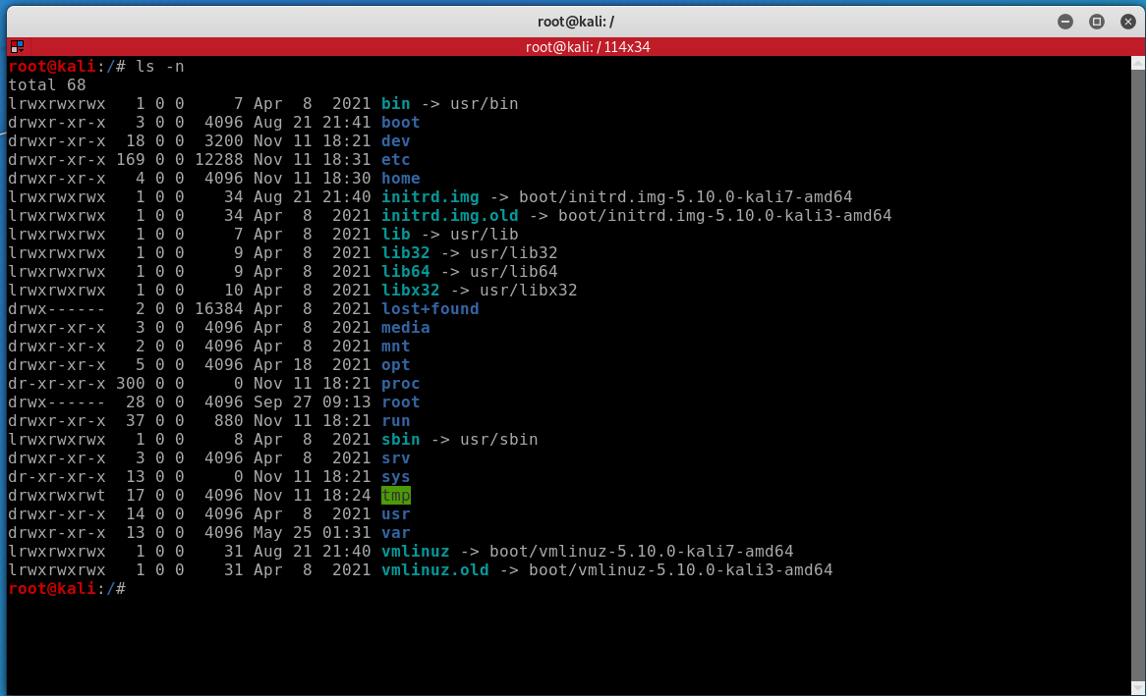

5.chmod to change permission

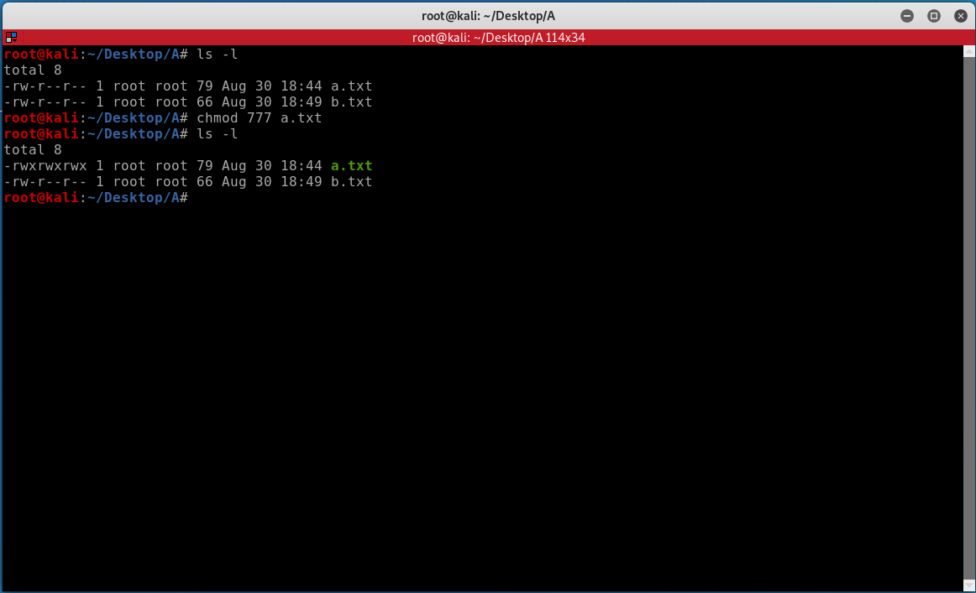

6.chmod to change permission

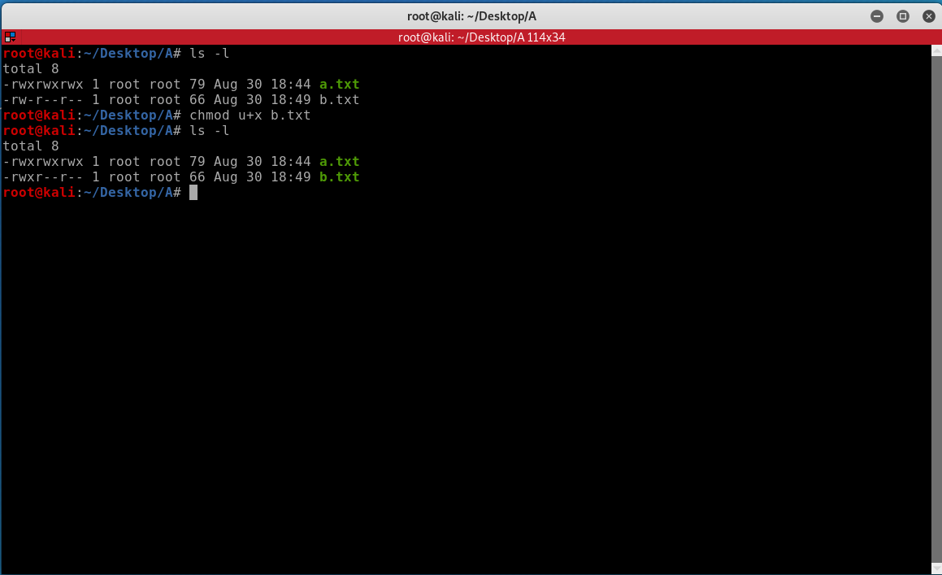

7. Default permission

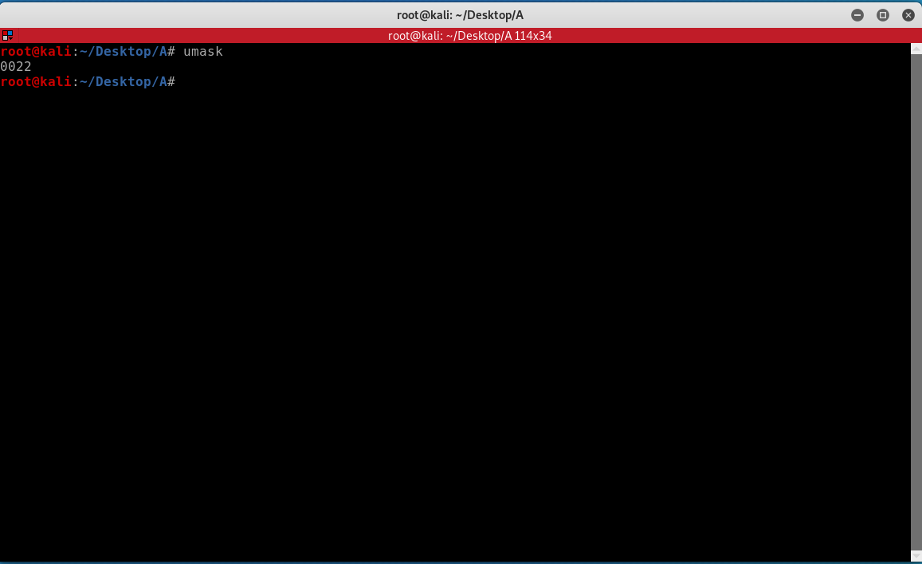

8. Permission for current Directory

